Escape From Battersea
Level Design Test / Ubisoft Singapore / Harry Luck
Table of Contents
Summary 1
Walkthrough 2
Part 1 2
Part 2 3
Part 3 4
Mechanics 5
References 6

Summary
The level I decided to create is based during a WWII era Battersea Power Station that has been converted for military purposes. It has been partially destroyed and a plane crashes into the side of the building.
The player will need to find a way out after parachuting off target through the roof and landing in a supply area of the building.
The main focus was acrobatic navigation. There is plenty of opportunity for NPC enemies in the location I have designed, but I decided to focus on the navigation for the test.

Notes
The 3D layout is complete but is missing some architectural elements (a roof for example), but all gameplay elements are there and any key architecture has been taken into account.
The Max file is organised into layers, one of which contains a first revision of the level. I decided to rebuild it because it wasn’t clean enough and as easy to organise. However, I thought I’d leave it in there for you to take a look at if you wished to do so.

Walkthrough

Part 1
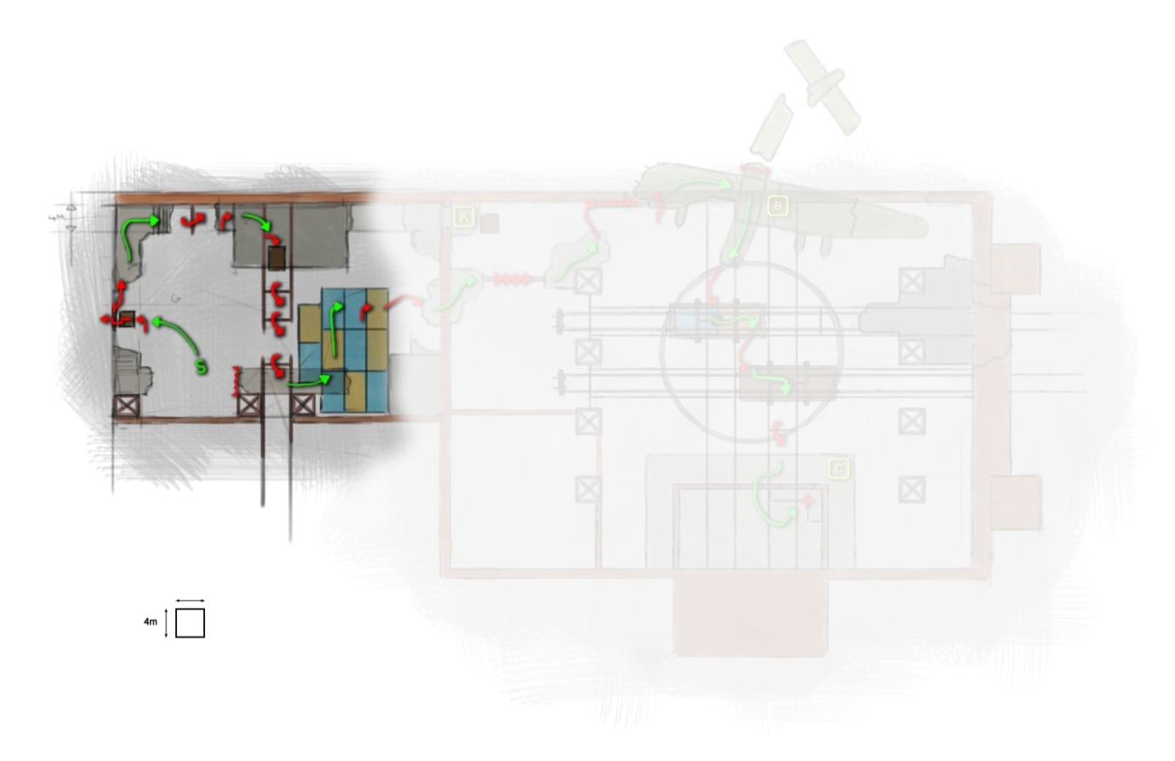
- The player parachutes through an opening in the roof and lands in a cargo/supply area
- After climbing to the top of a small office roof he must swing to an apparent exit
- When he swings to the third swing, it breaks and makes him fall to a platform below
- The platform he lands on is broken. However, the player can drop down to some containers stored below
- By climbing the containers he can then jump over to a broken floor to reach the next room

Part 2
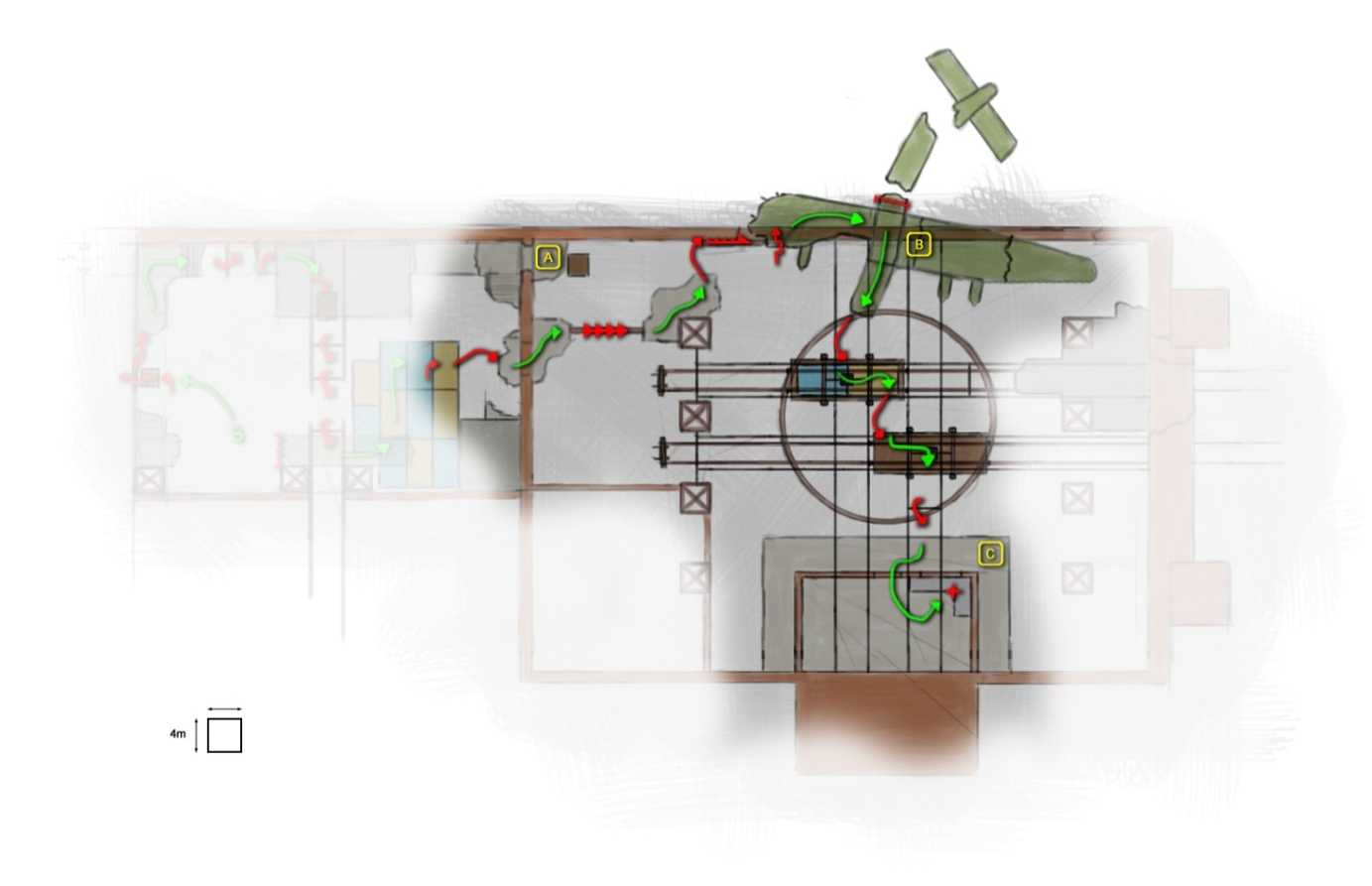
- The player moves into the main supply area of the building containing a rotating train car platform, a crane system for lifting the train cars and several actual train cars
- After crossing a narrow beam high above the ground, a plane smashes into the side of the building further preventing direct access for the player to reach his exit
- The player must use broken parts of the wall to shimmy to the plane and then pull himself up onto the wing
- Upon reaching the top of the plane the left wing breaks, creating a way back up if the player falls
- From this position the player can see a way up to one of the main chimneys through the wreckage but cannot reach them with the trains in their current position
- The player jumps across the two suspended train cars to reach the control room for the cranes

Part 3
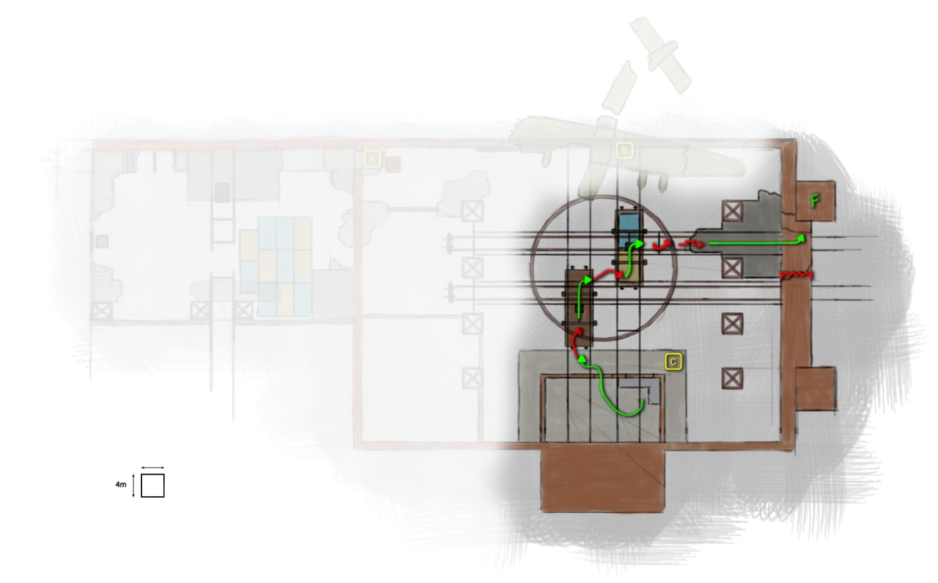
- After landing on the platform the player must go into the control room and rotate and alter the heights of the two suspended train cars
- When the player lands, some rubble will fall that creates a way back up to the control room area directly
- Once the train cars have been moved and rotated to the correct positions the player will be able to reach them
- After jumping across the train cars again, the player will now be able to reach the floor area he was unable to reach previously
- From here the player must run to the outside of the building to the chimney as the floor begins to crumble beneath his feet

Mechanics
I have added 2 mechanics to the list already provided in the tests guidelines. They are both movement related.
- A ledge jump allowing the player to jump to another ledge or land on a platform either side of him.
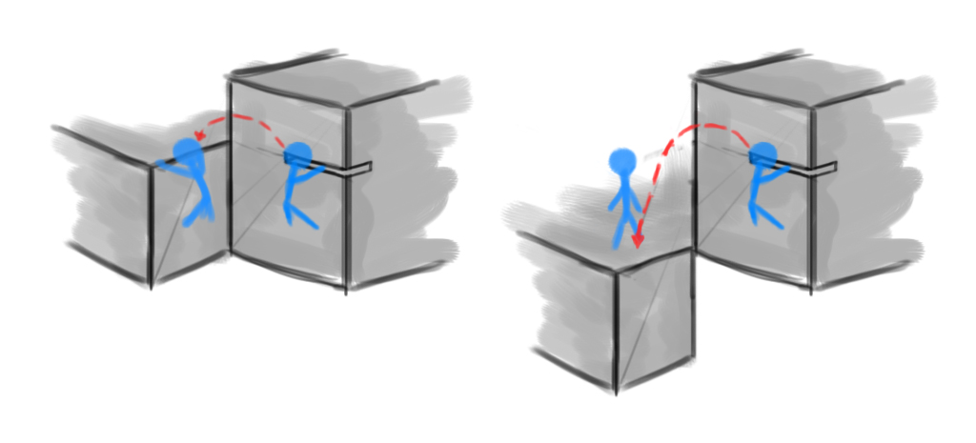
- A ledge to ledge vertical jump allowing the player to gain more vertical distance from a ledge stance as long as his feet are on something solid.
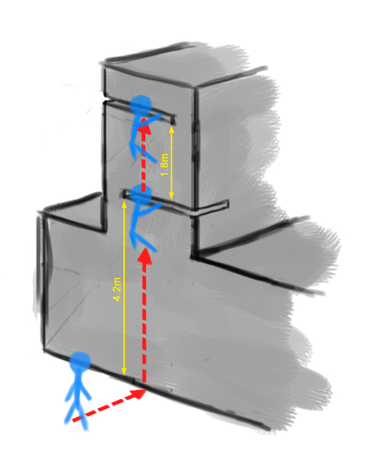

References
Battersea Power Station
A brilliant and iconic landmark of London that is perfect for the time period and setting of the war. Has lots of interior space to use both vertically and horizontally.
http://en.wikipedia.org/wiki/Battersea_Power_Station
Junkers Ju 390
A huge WWII German transport/recon/bomber plane. Is large enough to allow the player character a comfortable amount of room to move around on it.
http://en.wikipedia.org/wiki/Junkers_Ju_390
Rotating Railway Platform
A simpler version of the image below that allows train cars to be decoupled, rotated and moved to another train/track.
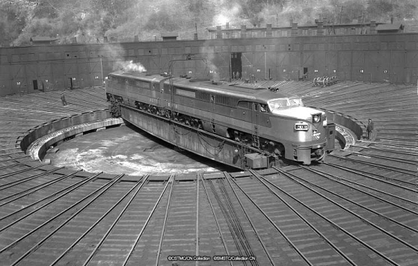
Gantry Crane
An overhead crane system for lifting and moving cargo in an interior space.
http://en.wikipedia.org/wiki/Gantry_crane

