|  |  |
| --- | --- |
| Harry Luck - Design Test |  |
|  | Senior Level Designer |

I have decided to use Uncharted as my reference game while answering the questions presented. It is a great franchise that managed to draw new blood from the previously Tomb Raider led genre when Tomb Raider seemed unable to really do or try anything particularly new. Although I find the amount of combat vs. exploration/puzzles can, at times, be a little frustrating, it is still an incredibly well rounded and extremely polished game with one of the best animation systems out there.

**Question A**

Uncharted 1 and 2 vary quite a lot when it comes to their levels. The obvious major addition to Uncharted 2 were the OTT cinematic sequences. Personally, I was not a huge fan of these as they ask the player to suddenly react to something they may not have encountered much so far or been used to doing so quickly. Sections like the truck driving towards the screen while you need to run away and shoot at it can at first be incredibly frustrating. However, the building blocks that made the first game great remained in place.

Uncharted's level design patterns or styles can really be split into three major categories:

* **Combat Arenas**
* **Platforming**
* **Puzzles**

These are the basic building blocks of every single level, generally speaking. There are breaks with tradition here and there (the sneaking section at the palace in Uncharted 2 for example), but apart from that the player will generally spend his time divided between running and jumping around a mostly combat free 'tunnel', before coming to a more open area with cover objects, weapon drops etc for combat or finding themselves somewhere where they are being asked to solve something to progress, push a number of switches etc. The puzzle areas usually incorporate one or both of the other building blocks as well. This helps break up the possible monotony of being asked to do one task over and over again, however, it can also be distracting when too many of the elements are combined or they switch back and forth too regularly.



Above is a simple sketch (not meant to show my artistic skills in any way! heh), that shows how an Uncharted level was commonly divided. At the start of the level (Zone 0) there is likely no combat and no excessive acrobatics required for traversal, usually a chance for the player character to talk about story with another character while taking in a couple of breathtaking vistas along the way. Then we move to a movement/platforming 'tunnel' section (Zone 1). Initially simple with varying degrees of difficulty as we progress through the game. This area is usually fairly confined and generally very linear. We then reach an open area (Zone 2), initially dotted with a couple of pieces of cover and a clear exit route we are not yet able to access. This area is more open with interactive objects like exploding barrels, destructible cover objects and collapsible elements and other hazards. Once enemies have been dispatched the task of traversing some of the remaining architectural elements and other outcroppings becomes possible in order to open a route to the next area. Obviously this is not every level, but it is a good overview of how many of the levels are divided and how the areas work together to ensure spacing between different tasks.

The mechanics themselves are fairly straightforward, but incredibly well balanced and polished. Jumping from object to object is fluid and usually clear to the player, certainly in Uncharted: Drakes Fortune. They made the correct choice of selecting a few mechanics and then ensuring those mechanics can be used often and in various ways to keep the player interested but also allow the designers to increase the difficulty of such elements over time. For example, take a look at climbing the signs in Uncharted 2. They are an incredibly simple construction of several climbable elements, but they require the player, even during that short space of time, to consider how to scale them to be sure they end up in the right position to jump to the hole in the building at the top. Very good use of that particular setup of the climbing mechanic.

From an artistic perspective it is clear that they wanted to create an immersive and 'photo-realistic' world while still keeping the gamey aspects they would require for players to understand level layouts and geography. One of the best examples of how the art direction was used to great effect for the player was at the Tibetan Monastery in Uncharted 2. The chance to use clear architecture to help guide the player as well as the obvious handholds etc that were coloured wood beams and such against a fairly monotone brick or stone helped make routing clear and legible. Technically the levels are impressive in their scale and well conceived for the best visual fidelity while still keeping to some form of old school zoning or portal system that usually asks the player to move through cleverly concealed S and U-bends periodically. But it is never noticeable enough to be obvious. They still manage to create the illusion of vastness, especially in the war torn city where you can see great distances at times. I can only assume this was achieved with multiple backgrounds for specific locations to create this illusion, but it works. Without knowing how these levels were really built it is hard to understand what sort of technical restrictions the level designers would have been under whilst designing/building the levels, but it seems clear to me that this was a designers game. The world and the story was built while art seemed to have been left to figure out how to make it look the best with what the designs they were given and generate their own technical constraints to work within the designs, that is certainly the impression I get.

The constraints for designers are not many for a game like Uncharted. Mostly it comes down to scaling the difficulty. The abilities of the players avatar to perform leap after death-defying leap, swing, roll and shoot all pretty seamlessly seems to have allowed the designers to go wild with them, Drake is generally fairly forgiving. However, it is clear that combat was considered just as important as traversal and is obviously why the bubbles of action vs. adventure, the platforming to combat arenas, were implemented and rigidly adhered to.

The level design really shines from all perspectives, technical, artistic and gameplay, when they managed to combine all the elements during the train section. This was obviously a technical challenge and it is clear that it uses some form of repeating environment sections until a task has been completed and then the level transitions perfectly into the next section. It was brilliantly executed and gave the player the chance to face combat as well as platforming on a now moving surface which, in itself, becomes a puzzle. It was very cinematic but without the need to take the player away from how he is used to playing or away from the action.

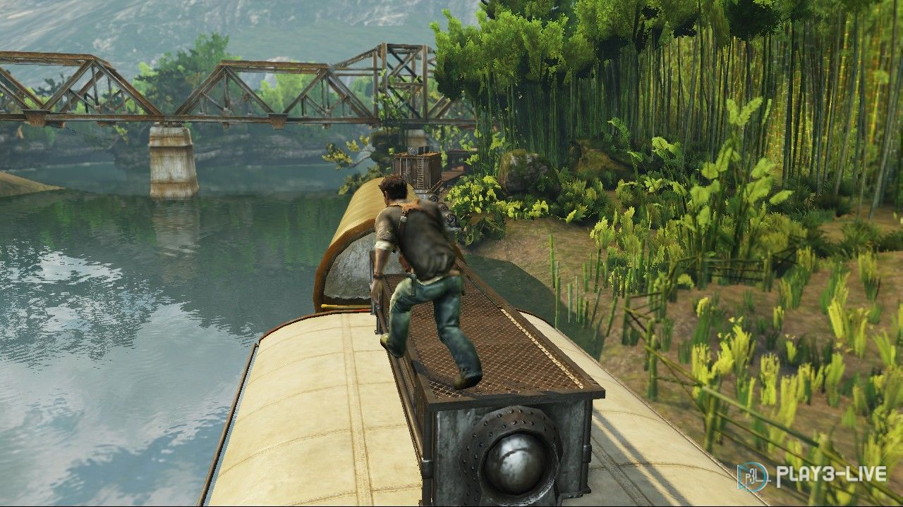

The opportunities for a level designer working on a project like this are huge. Due to the freedom of movement and acrobatic nature of the main character and the huge art team that was dedicated to this project the possibilities were endless, allowing them to vary environments hugely while still retaining all the key elements that make the game so compelling. I feel the narrative is a little too heavy in Uncharted 2 and can certainly get in the way, breaking the natural flow of the gameplay from time to time when the games strengths really are the key features and mechanics I have been discussing.

**Question B**

Although I am intending to work on Question C as my second focus, I wanted to mention something on Question B. Although the 'mechanic' I would have liked to see implemented isn't really a new feature I feel they missed a golden opportunity to present a slightly more immersive experience less through the narrative but more through cooperative AI features, think of something like Resident Evil 5 but not pointless! Although there were a few instances of this, they were usually cinematic in practice and not something that was a AI system design feature. This could allow the player some simple 'control' of a friendly AI with easy and context related requests. It could also allow the player an extra safety net in certain situations, allowing the friendly AI character to save you if you suddenly fall etc. If the friendly AI characters were given a slightly different skillset to the players character could also allow this aspect to be expanded on even further. For example:

* Distractions that allow the player to get behind enemies
* Focused attacks to take down enemies more quickly
* Divided levels where you are working together to get from one section to another

These are obviously just a few examples, but I wanted to point out something I feel would have definitely made me more attached to my compadres than the narrative alone managed to do. Even puzzles could become less frustrating if you had someone helping point you in the right direction initially also.

**Question C**

Generic modular level design, the holy grail for everyone except level designers! ;)

The first place to start is to decide what sort of system this would be. Would it be a system that will allow the end user to generate entirely random environments or a developer tool for creating a base to then refine? Could it instead be prebuilt environment sections that could be bolted together in various ways dynamically? Although this can also create a random environment, the variations would clearly be more limited and the actual sections themselves could quickly become recognizable or predictable, and thus boring.

For me the ideal solution is a hybrid of these two in my opinion. Using prebuilt environmental modular pieces that can then be constructed into sections that could be bolted together, rules should be acknowledged for how big sections or zones should be, how spread out each type of these should be and so on. For simplicities sake I would personally propose the use of a basic door or portal system to move from each large section to another. This would allow greater variability in the environment if everything does not have to lock together perfectly. Obviously a system like this would need extensive cooperation between level design and art both from a technical and visual aspect to ensure all the right pieces are built correctly and can be constructed sensibly.

From here, each section could be propagated with various 'clamps' for gameplay elements, enemy placement and pickups which would then be dynamically/randomly chosen after the level sections had been propagated.

This system could potentially run the risk of appearing too much like the old hack and slash random dungeons from years ago. However, with the right art direction and collaboration it could end up with the best and most varied results.

See the following examples to see how all the pieces could work together:

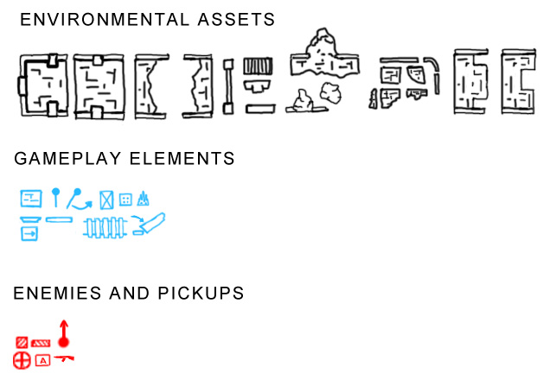



Environmental assets would be the building blocks for constructing the level. And would include simple walls, floors, steps, columns etc, as well as more complete sections of corridor etc. Gameplay elements would include all of the interactive or game mechanic related features such as swings, ledges, bridges, columns that could be knocked over, spike traps and falling floors (I know, old school!). Enemies and pickups include enemy spawn points, cover objects, health, ammo and weapon pickups.

All environmental assets should have relationships with one another, or rules, to determine what other pieces they are allowed to be connected to and how (using something like socket snapping in Unreal), weights that control how likely one piece will be linked to another and the scale/rotation extents for each of the pieces, if any.

With these rules, and many others, in place (and yes I'm taking a massive leap), we could end up with something nice and simple like this from the environmental assets: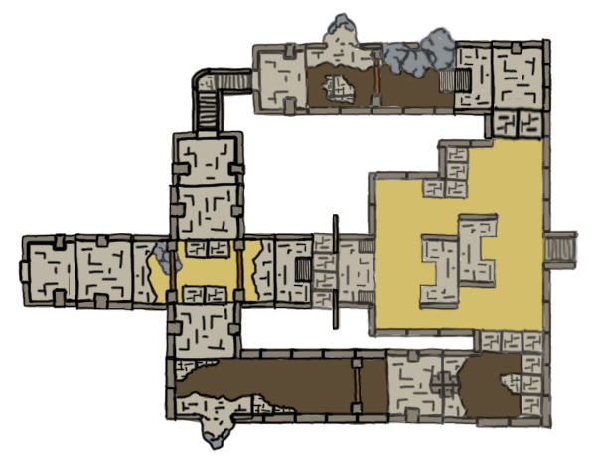This layout was literally just copy and pasted sections of the modular pieces placed together, essentially what the tool would need to do. In this case, we may have stated the necessity for 1 combat zone with 3 routes leading into the area from the initial starting location. Obviously there would need to be more controls about how the areas were created, but this is it in its simplest form. By allowing, as previously stated, the ability to essentially store this layout it could then be edited and perfected a little more to get a more precise version of what may have been wanted, look at the example below, edited to alter the layout after conception:

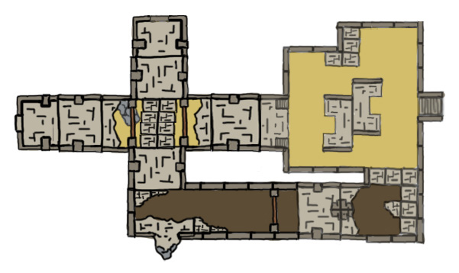

Once there is a basic layout that everyone is happy with you can begin to consider gameplay elements. The priorities of which elements override each other would need be based on the type of zone they are in and their proximity to other similar elements of opposing types. Below shows the 'clamps' for all possible elements that could appear in the level. The 'clamps' would likely need to be placed by hand, but the actual selection from those 'clamps' could then easily be automatic based on some simple rules. See below the possible elements on the left vs. the actual final selection on the right:

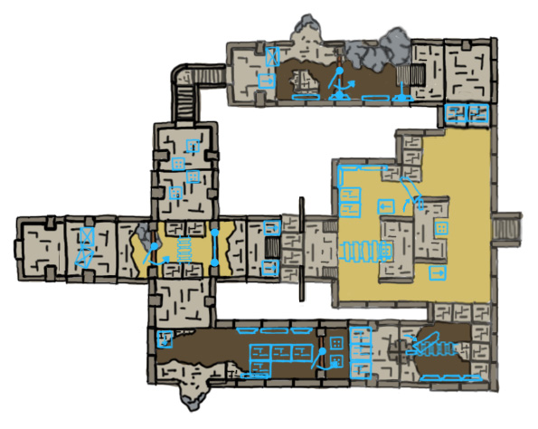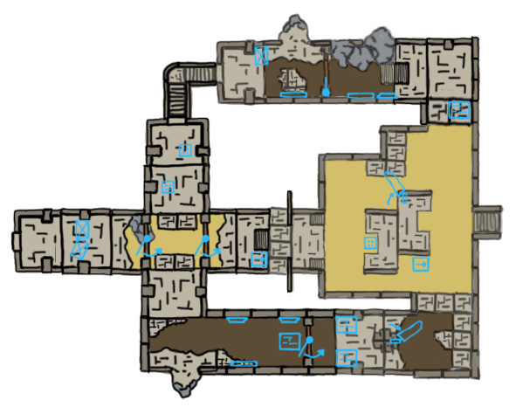

Then finally we have enemies, cover and items. This would be achieved in the same way as the other gameplay elements. Depending on the zone these are in would greatly alter their likelihood of appearing. For example, enemies, and ammo would be far more likely to appear in their placed positions if they are inside a combat zone rather than a platforming zone, though not impossible depending on the weights that could be predetermined. In a combat zone these would be more likely to override gameplay elements also. Below shows the possible placements vs. the final selection:

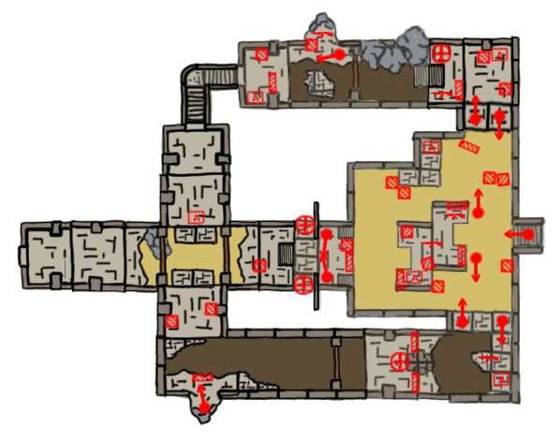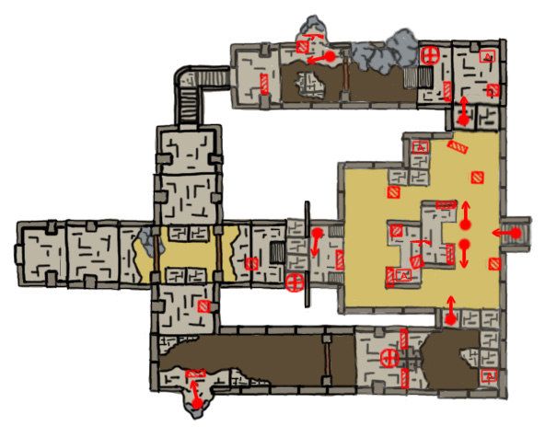

Ultimately the system would need to allow the flexibility to allow a development team to refine and alter any automatic creation system, especially when you consider the AAA games industry world we live in. I simply don't believe it would be feasible to create the kind of organic and/or vast and varied environments that are likely to be required without being able to control how these levels were constructed with more than just sliders and weighting variables etc. It could definitely be done, but would require a lot more than my day or two of consideration to pin down a truly working model that lies in the realms of plausibility! With that said however, I believe I have described, in brief at least, a viable option to achieve, at its most basic level, the automation requirements whilst keeping the absolutely necessary ability to change and polish the environments where necessary.

I have attached a zip-file along with this document that includes all of the images in here so you can take a look at them in slightly more detail if you so desire. I realize they are showing a very simple form of what would likely need to be a much more complicated system and my images are not the best, but I hope they give you a good idea of what my intentions are with this system.