HEAT EVENTS
Concept Design – Harry Luck
Contents
HEAT EVENTS 2
Summary 2
Goal 2
F2P Potential 2
EVENT EXAMPLES 3
Attention Seeker 3
Type 3
Goal 3
General Approach 3
Design Specifics 3
The Assassin 4
Type 4
Goal 4
General Design 4

HEAT EVENTS

Summary
In each arena there are multiple key locations that trigger HEAT EVENTS. These can be solo or team based.
Each HEAT EVENT is designed to task the contestant(s) with a specific goal or task to ensure all eyes are on him and increase his fame.
The faster, more stylishly, more explosively you take on these events the more the cameras will adore you; the more you will be watched…
Stardom within reach.

Goal
HEAT EVENTS are generally simple tasks/challenges for a single or multiple players to take part in in order to offer mini goals to players during the course of the game. By adding these to the general gameplay experience it helps offer greater choices to players as well as make the overall game experience a little deeper and fresh.
They also help increase the players exposure to the idea of heat and fame and allow them to potentially earn more of both. These events also ask the player to spend some of their heat in order to be a part of them which enhances the cycle of heat as a currency.
By adding these events, audience participation becomes more viable. Watching the game with these happening dynamically around the arena would make for far more interesting viewing and potential audience options.
Note: Every event must be designed to ensure the main gameplay focus doesn’t change. That it doesn’t break the base experience for the players or the audience, i.e. shooting and killing stuff!

F2P Potential
Each HEAT EVENT is exactly that, an event that requires your $$$ on to initiate it. You can either use your earned HEAT or… use your wallet!

EVENT EXAMPLES

Attention Seeker
Reach a location (randomly chosen from a list) in the arena and paint a target for demolition.

Type
Team

Goal
Shift the audience focus to an area in order to be watched by the cameras more intently to increase the chance that your endeavours are seen and thus increase your fame faster than usual within an area.

General Approach
- Any team member reaches a location to paint a pre-defined target (a building/old vehicle etc)
- Paint target to have it destroyed creating an attention zone
- Defend an expanding zone over time to gain fame/stardom multipliers
- If more enemies than friendlies are inside the area the multiplier is reset
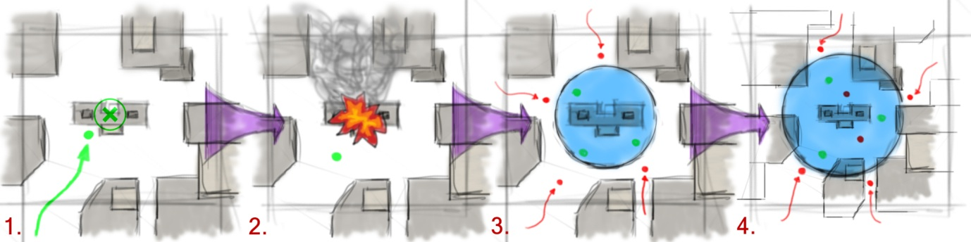

Design Specifics
Paint Target
After activating the event, each team member will receive an extra “weapon”, this “weapon” needs to be shot at a target to “paint” it for demolition.
- Requires a non-character to receive the same “damage” information as a character
Attention Zone
- This is a simple radial area that checks for a specific team once activated
- It will expand over a set time (in seconds) once activated creating a larger area to try and control
- If the zone has more enemies than friendlies at any point it will stop the crowd pleaser event and cancel out any fame multipliers
- When/if the timer reaches zero the area will be deactivated and a heat bonus will be given to each member of the team that took part

The Assassin
Take down 5 targets in succession, with each one needing to be taken down in less time. Doing so with extra flair; without damage, taunting prior to the kill etc., will award more fame.

Type
Solo

Goal
Show your artisan killing skills while attempting to take down 5 members of the opposing team in succession. As each one is taken down, you gain fame multipliers until you are taken down. If you reach the required 5 you will gain bonus heat.

General Design
- After activation you will be given a target to takedown
- When the target is killed, the kill and how it was achieved will be evaluated
- The next target will be activated
- When/if all 5 targets are killed the event ends and awards applied
- If the event is failed, it will be cancelled

